**Electric Vehicle and Charging Infrastructure Policy**

**Rules of the Road Working Group**

Electric vehicles (EVs) are becoming more prevalent on North Carolina’s roads, creating both challenges and opportunities. With an appropriate policy and regulatory framework, North Carolina can reap the economic and environmental benefits of being a leader in this field. On the other hand, failure to prepare for the changing market will result in business model upheaval and unexpected costs.

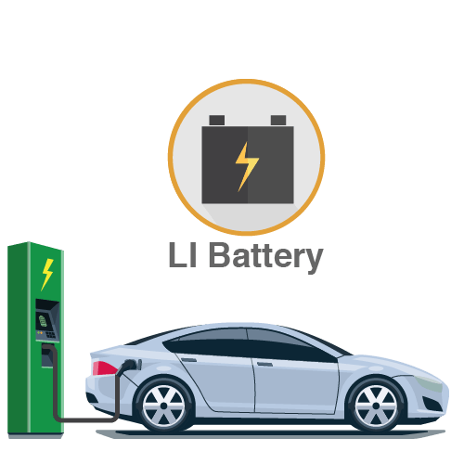NC Sustainable Energy Association (NCSEA) and our partners

are launching a collaborative dialogue

on the regulatory and policy rules of the road for North Carolina’s growing electric vehicle market. This conversation

will also include the issue of charging station infrastructure business models which is critical to the EV market.

**Challenges and Opportunities**

According to Navigant Research, in a few years the global revenue for electric vehicles and infrastructure will be nearly $6 billion. Statistics from the Electric Drive Transportation Association show that plug-in vehicle sales grew 37% in 2016 (vs. 2015) and are picking up more speed in 2017, with another 48% increase so far.

The transition to electric vehicles is becoming a high value component in the transportation, fueling and energy sectors. EVs and related infrastructure impact electric grids and driver processes. They also have the potential to be used as energy storage for use during peak demand periods.

However, as with any transformative innovation, there are growing pains. EVs may enhance or disrupt the current gas station/convenience store business model. In addition, the need for EV charging at work and home presents new demands on building level electrical systems put in place long before the vehicles became available. And, the way we collect revenue for road construction and maintenance has and will continue to change since most revenue is currently collected at gas stations.

**The current state of North Carolina’s EV market**

As electric vehicles become more prevalent on our roads, review and management of state policies becomes much more necessary. North Carolina is a hub of manufacturing components that go into electric vehicles or the charging infrastructure. Further, North Carolina is a prime

market for early and mid-technology adopters. However, to

date, state policy development has been done in a piecemeal fashion, looking at issues only as they arise, rather than proactively.

There are currently 17 models of electric vehicles available for purchase in North Carolina, with a dozen more models expected in coming years. Travel range for these vehicles are increasing dramatically and vehicle costs are declining. This transformation of our vehicle systems requires new policy thinking – charging of electric vehicles is a different concept than filling a gas tank. Our working group will work toward policies that benefit drivers, businesses, and utilities, and do not increase electric rates to non-EV owners.

Over the last decade, many groups have put the foundation in place for technology and education. These experts will participate in the next phase of planning by helping to guide policy makers. By engaging key stakeholders and potentially impacted industries, NCSEA’s Working Group will focus on policy and regulatory protocols that enable North Carolina to benefit from the rapidly changing EV market. The end result is intended to be a win-win-win situation, where local businesses are able to grow and thrive, drivers have cost-effective options to support their vehicle choices, and the North Carolina economy and environment improve.

**Goals of the Working Group**

North Carolina has an opportunity to continue leadership and economic development in the electric vehicle market. To do so, the state must develop clear and consistent policy that enables all facets of the market and new businesses growing to fill consumer needs.

NCSEA’s Electric Vehicle and Charging Infrastructure Working Group convenes an active dialogue toward the following goals:

1. Establish state policies that provide a level playing field for electric vehicles to enter the market and maximize benefits to the grid.
2. Enable multiple, scalable business models that leverage the private sector to rapidly deploy vehicle charging infrastructure.
3. Develop guidance that helps the state and local governments plan for increased adoption of electric vehicles and charging stations.
4. Ensure that Volkswagen Settlement funds are used effectively and efficiently and that the recommended 15% go toward EV charging infrastructure.

**Expected Working Group Participants**

* NC Sustainable Energy Association
* EV Manufacturers
* EV Charging Station Manufacturers, Installers, and Operators
* NC Department of Environmental Quality
* North Carolina Utilities Commission
* Electric Utilities
* NC Building Code Council
* Office building and multi-family building owner/operators

**Timeframe:** Initial two meetings from 9:30 a.m. – 1:30 p.m. on May 23rd and June 20th. Lunch will be served.

**Location:**

* NC Sustainable Energy Association offices at 4800 Six Forks Road, Suite 300, Raleigh, NC 27609.

Sources:

Pluginnc.com

<http://electricdrive.org/>